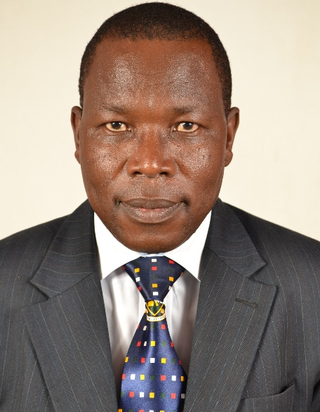
Prof Peter Wasamba
Peter Wasamba is a Professor of African Literature at the University of Nairobi. He has over 20 years of research and teaching experience at the university level. Prof. Wasamba has served as a university manager for over ten (10) years: as the Chairman, Department of Literature, Associate Dean and thereafter, Dean, Faculty of Arts. Wasamba has BA, MA and PhD degrees in Literature. He also has Bachelor of Laws (LLB) and Master of Laws (LLM) degrees, all from the University of Nairobi. He is an experienced gender trainer and researcher with several publications based on projects undertaken with collaborators. Wasamba is an international scholar involved in mentoring next generation academics and students through research and international collaborations.

